***PACKAGES***

library(package,mosaic,CARS,MASS,gplots,car)

***## BF[1] - Descriptive Statistics***

favstats(ivdata$Particles~ivdata$Companies)

par(mfrow=c(1,1))

plotmeans(ivdata$Particles ~ ivdata$Companies, error.bars="se")

## Option 1 for doing QQ plots

par(mfrow=c(1,1))

qqmath(~Particles|Companies,data=ivdata)

## Option 1 for doing Histogram

par(mfrow=c(1,1))

histogram(~Particles|Companies,data=ivdata)

***## BF[1] - Inferential Statistics***

womenpoet$type <- as.factor(womenpoet$type)

AnovaModel.2 <- aov(age ~ type, data=Womenpoet)

summary(AnovaModel.2)

##option #1 Checking equal variance and normality

par(mfrow=c(1,2))

plot(AnovaModel.1, which=1:2)

***## Transformation***

AnovaModel.1 <- aov(arctan(Particles) ~ Companies, data=ivdata)

summary(AnovaModel.1)

## When checking for transformations

favtats((ivdata$Particles)^(1/4)~ivdata$Companies)

***## BF[1] - Multiple Comparisons***

AnovaModel.1 <- aov(Particles ~ Companies, data=ivdata)

summary(AnovaModel.1)

favstats(ivdata$Particles~ivdata$Companies)

## Rstudio

testwn <- scheffe.test(AnovaModel.1, "Companies", group = TRUE, console = TRUE)

#Fisher's LSD

pairwise.t.test(ivdata$Particles, ivdata$Companies, "none")

#Bonferroni

pairwise.t.test(ivdata$Particles, ivdata$Companies, "bonferroni")

#Tukeys

TukeyHSD(AnovaModel.1, "Companies")

***## CONTRASTS***

meconium$groups <- as.factor(meconium$groups)

fit.lm1 <- lm(meconium ~ groups, data= meconium)

summary(fit.lm1)

contrasts(meconium$groups) <- cbind(c(.5,.5,-1), c(1,-1,0))

contrasts(meconium$groups)

fit.lm1 <- lm(meconium ~ groups, data= meconium)

summary(fit.lm1)

***## BF[2] - Descriptive Statistics***

pigout$B12 <- as.factor(pigout$B12)

favstats(pigout$WeightGain~pigout$Antibiotics)

favstats(pigout$WeightGain~pigout$B12)

par(mfrow=c(3,2))

boxplot(WeightGain~B12, data=pigout, id.method="y")

boxplot(WeightGain~Antibiotics, data=pigout, id.method="y")

interaction.plot(pigout$B12,pigout$Antibiotics, pigout$WeightGain)

interaction.plot(pigout$Antibiotics,pigout$B12, pigout$WeightGain)

plotmeans(pigout$WeightGain~pigout$Antibiotics, error.bars="se")

plotmeans(pigout$WeightGain~pigout$B12, error.bars="se")

***## BF[2] - Inferential Statistics***

par(mfrow=c(1,2))

plot(AnovaModel.1, which=1:2)

***## TRANSFORMATIONS***

favstats(log(pigout$WeightGain)~pigout$Antibiotics)

favstats(log(pigout$WeightGain)~pigout$B12)

AnovaModel.2 <- (lm(WeightGain ~ Antibiotics*B12, data=pig))

Anova(AnovaModel.2)

##option #1 Checking equal variance and normality

par(mfrow=c(1,2))

plot(AnovaModel.2, which=1:2)

***BF[2] - Type III Sum of Squares***

cancer326$gender <- as.factor(cancer326$gender)

## This gives us Type I Sum of Squares in R

AnovaModel.1 <- anova(lm(days ~ type*gender, data=cancer326))

AnovaModel.1

## This gives us Type III Sum of Squares in R

cancer.lm2 <- lm(days~gender*type, data=cancer326, contrasts=list(type=contr.sum, gender=contr.sum))

Anova(cancer.lm2, type="III")

***## CB[1] - Descriptive Statistics***

## Use BF[1] Descriptive Statistics

plotmeans(Fingertapping$fingertapping ~ Fingertapping$block, error.bars="se")

***## CB[1] - Inferential Statistics***

AnovaModel.1 <- lm(sqrt(Fingertapping$fingertapping)~Fingertapping$block+Fingertapping$drug)

Anova(AnovaModel.1)

AnovaModel.1 <- lm(Fingertapping$fingertapping~Fingertapping$drug)

Anova(AnovaModel.1)

##option #1 Checking equal variance and normality

par(mfrow=c(1,2))

plot(AnovaModel.1,which=1:2)

##option #2 Checking equal variance and normality

par(mfrow=c(1,2))

leveneTest(Fingertapping$fingertapping,Fingertapping$drug, center = mean)

qqPlot(AnovaModel.1$residuals)

hist(AnovaModel.1$residuals)

***## CB[2]/LS/ANCOVA***

## Latin Square Design

AnovaModel.1 <- lm(milk$milkyield ~ milk$cow + milk$weeks + milk$treatments)

Anova(AnovaModel.1)

AnovaModel.1 <- lm(milk$milkyield ~ milk$treatments)

Anova(AnovaModel.1)

##option #1 Checking equal variance and normality

par(mfrow=c(1,2))

plot(AnovaModel.1,which=1:2)

## This gives us Type III Sum of Squares in SPSS for ANCOVA

## Need car package

ancova.lm1 <- lm(score~confidenceratingmean*gender, data=confidence, contrasts=list(gender=contr.sum))

Anova(ancova.lm1, type="III")

## Need car package

ancova.lm2 <- lm(score~confidenceratingmean+gender, data=confidence, contrasts=list(gender=contr.sum))

Anova(ancova.lm2, type="III")

Anova(ancova.lm2, type="III")

##option #1 Checking equal variance and normality

par(mfrow=c(1,2))

plot(AnovaModel.1,which=1:2)

***## SP/RM[1,1] - Descriptive Statistics***

## Use BF[2] Descriptive Statistics

***## SP/RM[1,1] - Inferential Statistics***

splitplot <- aov(log(diabetic$LacticAcid) ~ diabetic$Method + as.factor(diabetic$Dog) + diabetic$Method*diabetic$Operations)

summary(splitplot)

F=320/63.5

1-pf(F,1,8)

##option #1 Checking equal variance and normality

par(mfrow=c(1,2))

plot(splitplot,which=1:2)

***## Power***

power.anova.test(groups=5, between.var=var(c(0,0,0,0,10)),within.var=11.67^2, sig.level=0.05, power=0.869)

power.anova.test(groups=5, between.var=var(c(0,0,0,0,10)),within.var=11.67^2, sig.level=0.05, n=25)

x <- rep(NA,20)

for (i in 2:20){

x[i] <- power.anova.test(groups=4, between.var=var(c(0,2,4,6)), within.var=4.7^2, sig.level=0.05, n=i)$power

}

x

i

n <- c(1:20)

scatterplot(x~n,reg.line=FALSE, spread=FALSE, boxplots=FALSE)

***## Models and definition***

-BF[1] – 1 factor Distance(far, close)

-BF[2] – two factors plus interaction Distance and throw (over, under)

-CB [1] – BF {1} plus minimize nuisance variable (thrower)

-SP/RM [1:1] – two factors, plus a block(people, only participate in one of the first factor)

-LS [1] – two confounding variables that we try to neutralize. AB, BA

-BF [3] – Three factors of interest

***## ANOVA-Doku***   
a. Within each cell the effect sizes are the same  
b. Sum of effects within each factor = 0   
c. Residuals sum within each cell = 0   
d. Cell mean = model fit = grand mean + all other effects

***## BF[1]***

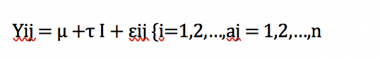

***## BF[2]***

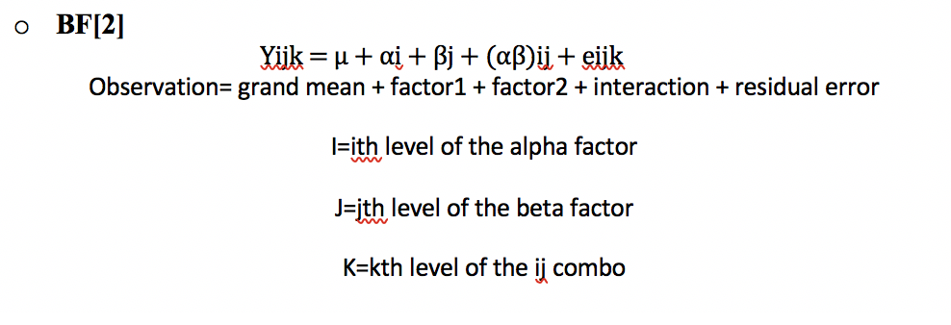

***## CB [1]***

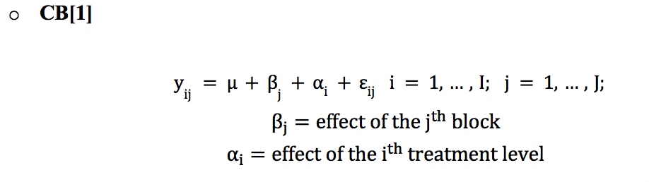

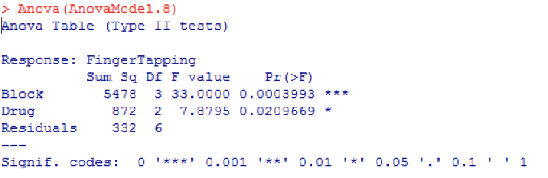

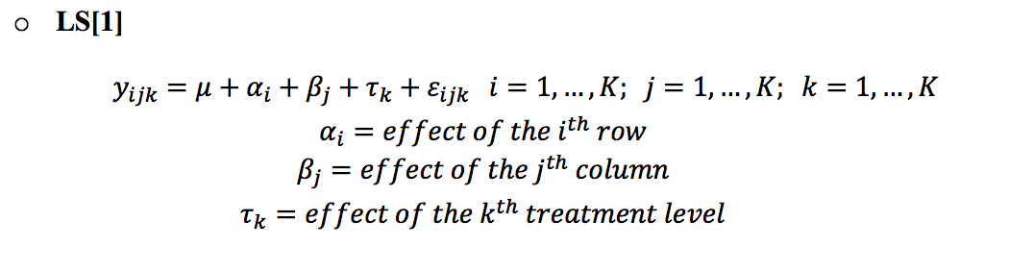

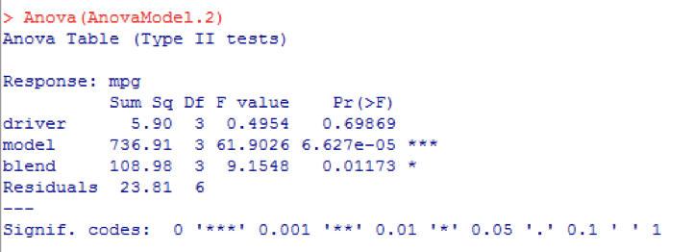

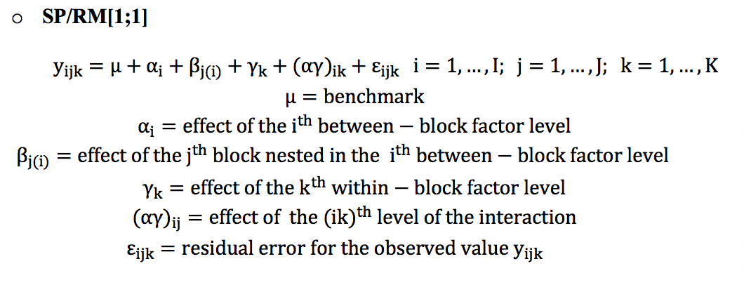

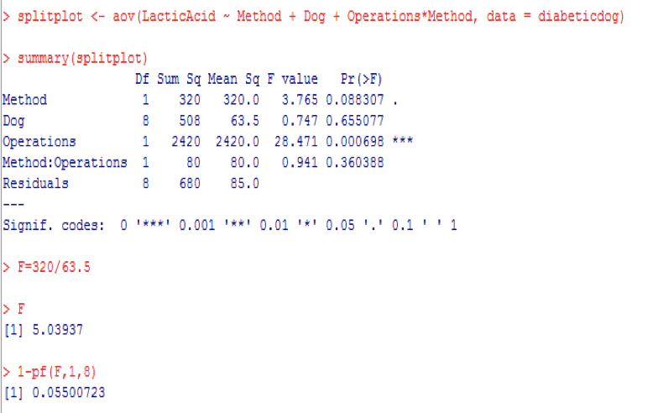

Writing the null and alternative hypothesis for any model.

BF[1]

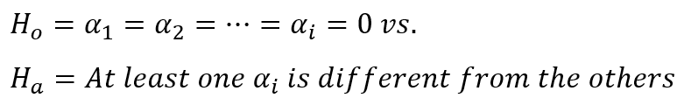

BF[2]

All of the null and alternative hypotheses

null: curriculum makes no difference

alt: curriculum makes a difference

null: study makes no difference

alt: study makes a difference

null: there is no interaction

alt: there is an interaction

SP/RM

H_0:The mean for each level of the between-block factor is the same

H_a: At least one of the means for the levels of the between-block factor is not the same

H_0:The mean for each level of the within-block factor is the same

H_a: At least one of the means for the levels of the within-block factor is not the same

H_0:No interaction with the betweenblock factor and within-block factor

H_a:There is an interaction with the betweenblock factor and within-block factor

CB[1]

null: mu1 = mu2

alt: mu1 is not equal to mu2

The degrees of freedom for doing any type of ANOVA F test.

BF[1]

grand mean = 1

treatment = whole-plot levels-1

residuals = number of observations-number of treatment levels

BF[2]

grand mean = 1

factor A = levels of factor A-1

factor B = levels of factor B-1

interaction = (df for factor A)*(df for factor B)

residuals = ((levels of factor A)*(levels of factor B))*(number of observations-1)

CB[1]

grand mean = 1

Block = number of blocks-1

treatment = number of treatments-1

residuals = (df for block)*(df for treatment)

SP/RM

Grand mean = 1

whole-plot = whole-plot levels-1

block = block levels-whole plot levels

subplot = subplot levels-1

interaction = (df for whole-plot)*(df for subplot)

residuals = (df for block)*(df for subplot)

Why do we randomize?

Reduce bias

Makes error behave in a chance like way

Why do we replicate?

An independent repeat of an experimental condition so that variability can be estimated

Not the same as repeated measurements on the same experimental unit.  Replication means assigning the same experimental units to the same treatment

For replication, it is precision (think law of large numbers) and have an estimate of the error (or residuals) so that you are able to test main effects and interactions and get F-tests and p-values for the main effects and interaction.

What are the following items in an experiment:

Factors- a meaningful partition of the observations p.164

Levels of a factor- the groups for a factor p.165

Treatments- conditions that can be assigned p.16

Blocking (if any)- a way of converting unplanned, systematic variation into planned,systematic variation by grouping p.16

Experimental Unit- the chunk of material that is assigned a treatment p.16

Response Variable- the response is the measurement you use to judge the effect of the conditions. p.110

Interaction (if any)- p.210

What is the definition of an interaction? – pg 210

there are three essential pieces to the structure of interaction: two crossed factors and a response. interaction is present if the effect of one factor , as measure by differences in the response averages, is different for different levels of the other factor

Why do we do a “blinded” study?

to avoid bias/any undue influence, avoid confounding, aka: keep things clean